Christian pro-life evangelistic witness at Anti-personhood bill, Romanist/ecumenical, SC chapter of National Right to Life
annual event - January 17, 2009

Each year before the anniversary of Roe v. Wade, the SC chapter of the Vatican's "front" Ecumenical "pro-life" [not] organization, National Right to Life (originally founded by the National Conference of Catholic Bishops in 1968, before ostensibly becoming "autonomous" and "non-sectarian" [any religion] in 1973), conducts a March & Rally on a Saturday midday. Although the attendees are a majority Roman Catholic, unfortunately a number of evangelical Christians also join in to march and rally
with Rome, despite the fact that there is also now an annual Christian rally on the north steps of the
SC State House on the January 22 Roe anniversary, including Christian pastors for speakers; and
then also a Christian Outdoor Worship Service to Repent for America's Corporate Bloodguilt on
the Sunday prior to the Roe anniversary.

REPENTANCE FOR AMERICA'S BLOODGUILT OUTDOOR WORSHIP SERVICE - Press Release
Sunday, January 18, 2009 - South Steps, SC State House, Columbia, South Carolina
www.christianlifeandliberty.net/2008-12-26-REPENTANCEforAMERICA'SBLOODGUILT.doc

Catholic Bishops in Georgia, Montana, and Colorado opposed state personhood amendments for the pre-born

Judie Brown column
"We remain steadfast, but..."
www.renewamerica.us/columns/brown/080307

Judie Brown is a principled "pro-personhood" pro-lifer. Her national organization, American Life League, has provided
information, materials, education, and advocacy for the personhood of the pre-born for many years. Judie Brown is also
Roman Catholic. Her accurate article cited above, reporting the non-support and opposition of the Catholic Bishops in three states: Georgia, Montana, and Colorado, can be verified and readily independently documented by a variety
of on-line resources.

"Judie Brown is president and co-founder of American Life League, the nation's largest grassroots pro-life educational organization."

I admire Judie Brown's principled pro-life position and her courage to speak the truth. I also pray she will be delivered
from the false teaching of the Roman Catholic religion. If she is not already saved, I pray that she will be born-again,
saved by grace alone, through faith alone, in the Saviour alone.

Roman Catholicism is NOT Biblical Christianity
http://lefemineforlife.blogspot.com/2008/04/roman-catholicism-is-not-biblical.html

However I will also add that the non-support and opposition of the hierarchy of the Roman Catholic Church,
as manifested by the non-support and opposition of the seven bishops from three states (GA, MT, CO) explained in Judie Brown's informative article (link above), is paralleled, by the non-support and opposition of the National Right to Life Committee.

Here in South Carolina, the executive director of the SC chapter of National Right to Life actually approached
the SC House legislator who was the primary sponsor of the "Right to Life Act of SC" Personhood Bill, and
tried to dissuade him from further advocacy of the bill. SC Citizens for Life tried to kill the SC Personhood Bill.

Similar experiences with non-support by National Right to Life has been experienced in other states as well.
(see the links to related articles below)

So principled "pro-personhood" pro-lifers have two additional enemies they may not have realized were actually working against their efforts to establish personhood for the pre-born with state-level personhood bills and constitutional amendments: the Roman Catholic Church hierarchy (bishops and above, all the way to the Vatican), and National Right to Life.

To paraphrase what Oswald Chambers says in so many words in a couple of his daily devotionals in "My Utmost For His Highest" - "Good" is the ENEMY of God's "Best." The incrementalist, abortion-murder regulation strategy of National Right to Life, is the ENEMY of those principled "pro-personhood" pro-lifers who are working to not just "regulate" abortion, but to END it !

God's requirement for Murder is Justice, not Regulation !

"The Lord reigneth; ... righteousness and judgment are the habitation of His throne." Psalm 97:1a,2b

Steve Lefemine, pro-life missionary
dir. Columbia Christians for Life
Columbia, South Carolina
January 27, 2009 / Revised February 4, 2009 / Revised March 8, 2009
____________________________________________________________________________________________

Anti-personhood bill, Romanist/ecumenical, SC chapter of National Right to Life
Annual March & Rally
Saturday, January 17, 2009
Columbia, South Carolina

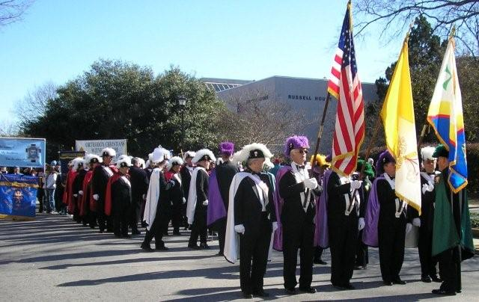
Large contingent of Roman Catholic Knights of Columbus (men's fraternal order), who led the Catholic and Christian
marchers from Greene Street, to Sumter Street, to the SC State House grounds for the rally near the south steps.

It is laudable that men, whether Christian or unsaved, should stand up for the right to life of pre-born children.
A man does not have to be saved to know that murder is wrong. However what is not pleasing to God is to
witness born-again, evangelical Christians, marching behind Rome's banner. God says we are not to be
unequally yoked with unbelievers (2 Corinthians 6:14-18). May God bless these Catholic men with spiritual
eyes to see His Truth in the Bible, and deliverance from the false church of Rome (as God delivered this author
in 1989). However, we as born-again Christians must love God more than even the innocent unborn
being slaughtered by the wicked, and obey Him in what He commands believers in 2 Cor. 6:14-18:

More Than These: A Call for Reformation
By Pastor Ralph Ovadal, 270 pages
Gift of $8 per copy
Now available online! Click here to read!
www.pccmonroe.org/Resources.htm
Meanwhile, SC Republican Governor [2008 Bilderberg attendee Mark Sanford], the SC Republican-majority
House of Representatives (71 R, 52 D, 1 vac.), Speaker Bobby Harrell, R-Charleston), and the SC Republican-majority Senate (27 R, 19 D, Senate President Pro-Tem Glenn McConnell, R-Charleston), continue to protect the murderers (Planned Parenthood, et al.) "right" to slay the innocent and shed their innocent blood, by REFUSING to pass
the Right to Life Act of SC "Personhood" bill, first filed in February 1998, and active now for 10 years, 1998-2008, so far in the SC Legislature.
www.scstatehouse.gov/html-pages/house2.html
www.scstatehouse.gov/html-pages/senate2.html
SC Governor Mark Sanford attended the 2008 meeting of the Bilderberg group
Meeting of Globalist Elites Bilderberg group held in Chantilly, Virginia - June 5 through June 8, 2008
http://lefemineforlife.blogspot.com/2008/06/sc-governor-mark-sanford-attended-2008.html

See history of Right to Life Act of SC "Personhood" Bill at: www.ChristianLifeandLiberty.net,
"RTL Act of SC" page, and also at: www.RighttoLifeActofSC.net

See report on end-of-session news conference at SC State House, May 27, 2008:

RIGHT TO LIFE ACT OF SC Personhood bill - End Abortion in SC
- SC State House News Conference - May 27, 2008
REPUBLICAN SC LEGISLATURE Continues to Fail to ESTABLISH JUSTICE:
To Protect the Lives of Over 7,000 Pre-Birth Children Murdered Each Year in SC by Surgical Abortion !
Right to Life Act SC Personhood bill - TEN YEARS ! 1998-2008
http://righttolifeactofsc.blogspot.com/2008/10/right-to-life-act-of-sc-personhood-bill.html

Link to graphic design of sign pictured in the 5/27/08 news conference report:
REPUBLICAN SC LEGISLATURE Continues to Fail to ESTABLISH JUSTICE:
www.christianlifeandliberty.net/signscrepublicansfailtoprotect.pdf

____________________________________________________________________________________________

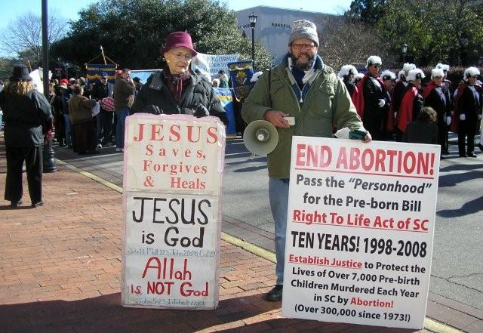
Anne Rainville and Steve Lefemine on sidewalk next to march assembly area (Greene St., USC Russell House Student Union), of anti-personhood bill, Romanist/ecumenical, SC chapter (SCCL) of National Right to Life on Saturday, January 17, 2009.

Many opportunities to pass out Mr. Ralph Ovadal's (pastor) brochure, "An Urgent Plea to Roman Catholics"
along with Gospel of salvation tracts (well over 200 sets distributed), to marchers, a large percentage of whom
were Roman Catholic. Christians are called to speak the truth in love (Eph. 4:15); pretending that Romanism
is Biblical Chistianity is neither truth, nor love. True love, according to 1 Corinthians 13, "rejoiceth in the truth;" (verse 6b,KJB). Christians who love Catholics will tell them the truth !

An Urgent Plea to Roman Catholics
Gift of $.07 each
www.pccmonroe.org/Resources.htm
www.pccmonroe.org/Ecumenism/urgent.htm
While preaching to the predominantly Catholic crowd, Steve asked the question how many wanted to see abortion ended ?
Both Steve and Anne perceived that most of the crowd indicated that was their desire, by their positive response to
Steve's question. And yet here they are joining in a march and rally sponsored by the SC chapter (SCCL) of the Vatican's "pro-life" [not] "front" organization, i.e., National Right to Life, that has resisted, opposed, hindered, and obstructed personhood legislation in multiple states (see links to related articles below), thinking that SCCL is trying to end abortion. In reality, for about two decades now, the legislation introduced by SCCL has been designed to R-E-G-U-L-A-T-E Child-Murder-by-Abortion. They have been doing incrementalist, abortion-murder regulation bills for over 19 years [SCCL's first "successful" legislation was the "Parental Consent" bill in 1990 - http://sclife.org/ - a grandparent must give his or her consent to have their grandchild that has been conceived in the womb of their minor daughter aborted, and THEN the innocent pre-born baby can be killed, butchered, slaughtered, destroyed. THAT, is considered "pro-life" legislation by those of the incrementalist abortion-murder regulation philosophy at South Carolina Citizens for Life (SCCL), and those deceived pro-lifers who think, "Well, at least we're saving some."

Yes, as Oswald Chambers, in his classic devotional, "My Utmost For His Highest" says in so many words:
"Good" is the ENEMY of God's "Best." The "good" of reducing the number of abortions, has resulted in pro-lifers surrending the moral high-ground, biblical principle, spiritual authority, and God's blessing, by disobeying God; resulting in the extension, perpetuation, and delaying of the day when abortion is finally OUTLAWED, not just Regulated !!! This outcome is not surprising when Christians follow Rome instead of the Word of God. The Bible says, "Thou shalt not kill [murder]." Exodus 20:13, KJB.

"God's requirement for Murder (e.g., abortion) is JUSTICE, not Regulation !"

After preaching on Personhood (virtually all were not even aware of the recent Colorado Personhood Amendment effort), Steve transitioned into a Gospel of salvation message, expressing that as important as is keeping the Law (e.g., the Sixth Commandment), we are not saved by the Law, but by grace, through faith, in our Lord and Saviour. By the grace of God, the preaching was received (surprisingly) without opposition, perhaps because of the inital
pro-life message, and the emphasis on Scripture in the message, and the fact that pointing out the many errors
of Roman Catholic doctrine and teaching was not the emphasis of this message, at this location, though some such points were mentioned.

____________________________________________________________________________________________

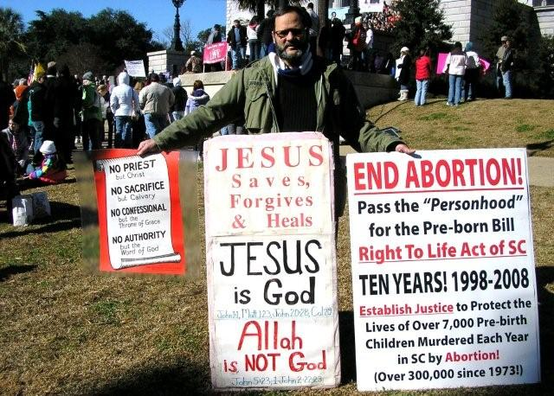
Steve Lefemine at SC State House behind rally (vicinity south steps) of anti-personhood bill, Romanist/ecumenical,
SC chapter (SCCL) of National Right to Life on Saturday, January 17, 2009.

This small sign was published by The Protestant Truth Society, 184 Fleet Street, London EC4A 2HJ
( www.protestant-truth.org/ ):

NO PRIEST
but Christ

NO SACRIFICE
but Calvary

NO CONFESSIONAL
but the Throne of Grace

NO AUTHORITY
but the Word of God

[addressing some of the doctrinal errors of the Roman Catholic institution's false teaching and unbiblical practice]

____________________________________________________________________________________________

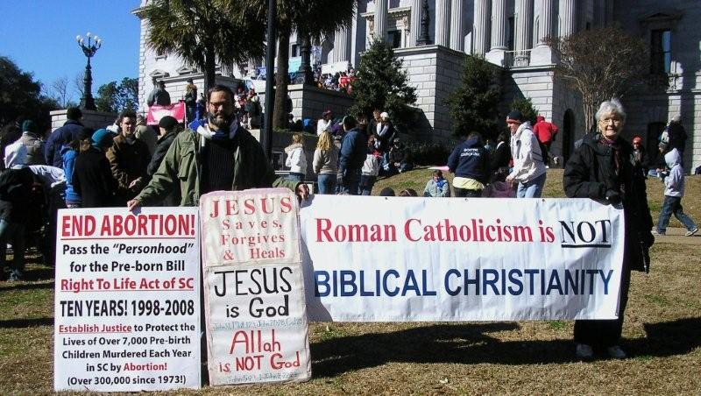
Steve Lefemine and Anne Rainville at SC State House behind rally (vicinity south steps) of anti-personhood bill, Romanist/ecumenical, SC chapter (SCCL) of National Right to Life on Saturday, January 17, 2009.

There were many opportunities for discussions and debates, especially with Catholic young people, over a range of Biblical and doctrinal issues. This experience was, to say the least, far more confrontational, and yet also much more interactive, than the witness in the march assembly area. Clearly, the large banner, "Roman Catholicism is NOT BIBLICAL CHRISTIANITY" was definitely something that provoked conversation.

Lord, you came "TO PREACH DELIVERANCE TO THE CAPTIVES,..." Luke 4:18
Your Word, the Bible, says, "And ye shall know the truth, and the truth shall make you free." John 8:32

Lord, please set free those who are seekers of You, and seekers of Your Truth. Set them free from the spiritual bondage of Romanism, and bring them into the Kingdom of Messiah, even as you have likewise set multitudes free over the centuries !
_____________________________________________________________________________

Columbia Christians for Life, Columbia, South Carolina

From: www.ChristianLifeandLiberty.net, "RTL Act of SC" page:

National Right To Life: The Judas Of The Preborn
By Dr. Patrick Johnston ; The Covenant News ~ July 10, 2006
www.christianlifeandliberty.net/H3213-S111-159.doc

Anti-abortion constitutional amendment petition falls short in Michigan
National Right to Life does it again - this time in Michigan...
Right to Life of Michigan did not support the petition drive to ban abortion in Michigan
by a state constitutional amendment, and neither did the Michigan Catholic Conference.
www.christianlifeandliberty.net/H3213-S111-160.doc

SC's National RTL chapter not supporting RTL Act of SC
- Is SC Citizens for Life really "Pro-Life" ? (flyer for distribution included)
www.christianlifeandliberty.net/RTLAofSC-07-12.doc

2007-2008 State-Level Personhood (and other selected) Legislation
- Including State-Level Personhood Bills and Constitutional Amendments
- AL, CO, GA, MT, SC, VA
Updated February 14, 2008
http://righttolifeactofsc.blogspot.com/2008/02/2007-2008-state-level-personhood-and.html

____________________________________________________________________________________________

Personhood Amendment in Colorado (ballot initiative November 4, 2008)
Personhood Amendment in Maryland (2009 legislative session)
Peresonhood Bill in South Carolina (2009 legislative session)
____________________________________________________________________________________________

Colorado Personhood Amendment to State Constitution - results of November 4, 2008 ballot initiative
Amendment 48-Definition of Person Results
http://data.denverpost.com/election/results/amendment/2008/48-definition-of-person/
100% reporting ( 3215 precincts )
Ballot-Vote Vote percentage Vote count
No 73.2% (1,605,978)
Yes 26.7% (585,561)

There is a published report that a Personhood Amendment to the State Constitution is to be introduced
in the Maryland State Legislature:
www.times-news.com/local/local_story_030231824.html
Published: January 30, 2009
CUMBERLAND A Republican lawmaker from Anne Arundel County is building support for a Personhood Amendment to the state Constitution and plans to introduce a bill “to a somewhat reluctant legislature”
as soon as next week.

The Right to Life Act of South Carolina "Personhood" Bill is expected to be introduced soon in the SC House.

_____________________________________________________________________________
_____________________________________________________________________________

Roman Catholicism is NOT Biblical Christianity
http://lefemineforlife.blogspot.com/2008/04/roman-catholicism-is-not-biblical.html
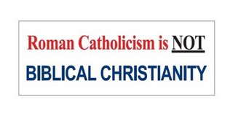
Five Reasons Why Roman Catholicism is not Biblical Christianity
www.ianpaisley.org/tiara.asp?printerfriendly=true

Evangelism to Roman Catholics by a former Roman Catholic priest:
The www.bereanbeacon.org/ website is the ministry outreach of former Catholic priest Richard Bennett.

The Pope Kissing The Koran
www.deceptioninthechurch.com/popekiss.html

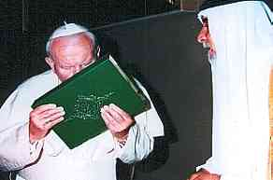
Here is a photo of the Pope at the end of an audience with Patriarch Raphael I of Iraq where "the Pope bowed to the Muslim holy book the Qu'ran presented to him by the delegation and kissed it as a sign of respect".

"The Two Babylons - Romanism and Its Origins," by Alexander Hislop (1916):
www.chick.com/catalog/books/0185.asp
"Where did the practices and beliefs of Roman Catholicism come from? In this scholarly classic, first published over eighty years ago, Alexander Hislop reveals that many Roman Catholic teachings did not originate with Christ or the Bible, but were adopted from ancient pagan Babylonian religion, and given Christian names."

Pope: Roman Catholic 'Church' only one true church
Repeating centuries of history, Rome has once again revealed its own dominion theology of primacy, and indeed, sole legitmacy, as the only true "church" on earth, in a document approved by the current false prophet occupying the antichrist Vatican, Pope Benedict XVI, on June 29, 2007. This blasphemous, perverted assertion is in fact just the opposite of the Truth. The false religion of Romanism is NOT Biblical Christianity, but is in fact a "Christianized" form of the ancient pagan religion of historical Babylon.
www.christianlifeandliberty.net/CATHOLIC-07-01.DOC

Faithful Christian Church Stands Against Pagan Shrine to Roman Goddess Worship in La Crosse, Wisconsin, USA
"We Stand Against the Goddess Worship in La Crosse." - Pilgrims Covenant Church, Mr. Ralph Ovadal, pastor.
http://lefemineforlife.blogspot.com/2008/08/faithful-christian-church-stands.html

Rome's Pope to meet Muslims; furthers NWO goal of one-world (false) Religion
The anti-Christian New World Order (NWO) has three main planks:
1) one-world civil ('political') Government
2) one-world Money
3) one-world (false) Religion
http://lefemineforlife.blogspot.com/2008/03/romes-pope-to-meet-muslims-furthers-nwo.html
Bush's Mideast Crusade for the Vatican a Betrayal of Patriotic Americans
Vatican public "opposition" to the Iraq War is a fraud, a "false flag" operation.
www.VaticanAssassins.org (Jesuits)
http://lefemineforlife.blogspot.com/2008/05/bushs-mideast-crusade-for-vatican.html

George W. Bush, the Catholic President
"A Catholic Wind in the White House"
The Washington Post, Sunday, April 13, 2008
http://lefemineforlife.blogspot.com/2008/05/george-w-bush-catholic-president.html

Kissing the Slippered Toe of the Pope :
Will George W. Bush do in real life what he acted out as a Skull and Bones initiate ?
Pope to visit George W. Bush in the White House on Wednesday, April 16, 2008.
http://lefemineforlife.blogspot.com/2008/04/kissing-slippered-toe-of-pope.html

Sovereign Head of Vatican City State (Pope) to visit the USA April 15-20, 2008
- "Supreme legislative, executive, and judicial power is vested in the pope,..."
- The pope "serves concurrently as bishop of Rome, supreme pontiff of the
Universal Church [sic], primate of Italy, archbishop and metropolitan of the
Province of Rome, and sovereign of the Vatican City State."
http://lefemineforlife.blogspot.com/2008/04/sovereign-head-of-vatican-city-state.html

Sovereign Head of Vatican City State (Pope) to visit the USA April 15-20, 2008
http://lefemineforlife.blogspot.com/2008/03/sovereign-head-of-vatican-city-state.html

_____________________________________________________________________________
_____________________________________________________________________________

AMERICA - A NATION UNDER DIVINE JUDGMENT.

Psalm 33:12; Proverb 14:34; Psalm 9:17; 2 Kings 24:1-4; Jeremiah 19:3-5; Psalm 106:37-42

"America repent" (music video)
"Contemporary Christian Artist: Tim Juillet"
www.youtube.com/watch?v=pvu6hHLSpzk

"The wicked shall be turned into hell, and all the nations that forget God."

Psalm 9:17, KJB

"But judgment shall return unto righteousness: and all the upright in heart shall follow it."

Psalm 94:15, KJB

Biblical "Separation" for a Nation
"Be ye not unequally yoked together with unbelievers: for what fellowship hath righteousness with unrighteousness? and what communion hath light with darkness? And what concord hath Christ with Belial? or what part hath he that believeth with an infidel? And what agreement hath the temple of God with idols? for ye are the temple of the living God; as God hath said, I will dwell in them, and walk in them; and I will be their God, and they shall be my people. Wherefore come out from among them, and be ye separate, saith the Lord,..." 2 Corinthians 6:14-17a (KJB)
THE DECLARATION OF INDEPENDENCE - IN CONGRESS, JULY 4, 1776
When in the Course of human events, it becomes necessary for one people to dissolve the political bands which have connected them with another, and to assume among the powers of the earth, the separate and equal station to which the Laws of Nature and of Nature's God entitle them, a decent respect to the opinions of mankind requires that they should declare the causes which impel them to the separation. The Declaration of Independence is part of the organic law of the United States of America United States Code Annotated http://uscode.house.gov/search/criteria.shtml
http://lefemineforlife.blogspot.com/2007/10/biblical-separation-for-nation.html

The people of Iraq have far greater freedom to enshrine their national religion of Islam in the legal structure of their country than do Americans to honor Christianity and Biblical Law in the United States. Christianity was by far the predominant faith of the founding generations of America, from Jamestown in 1607 to the Declaration of Independence in 1776, and beyond, as the historical record clearly shows:

No King but King Jesus! ((Yeshua Messiah)
Declarations and Evidences of Christian Faith in America’s Colonial Charters, State Constitutions,
and other Historical Documents during over 375 Years of American History: 1606 to 1982
www.christianlifeandliberty.net/NoKingbutKingJesus.doc

The Sixth President of the United States, John Quincy Adams (son of John Adams, the Second US President, and
a signer of the Declaration of Independence), said: "The highest glory of the American Revolution was this; it connected
in one indissoluble bond the principles of civil government with the principles of Christianity." and "From the day of the Declaration... they (the American people) were bound by the laws of God, which they all, and by the laws of The Gospel, which they nearly all, acknowledge as the rules of their conduct." Tragically, today in 2008, American law has become exceedingly anti-Christian. Witness the government-protected murder of One Million pre-birth human beings each year (www.ldi.org).

The Constitution of the United States should be amended as first proposed by the National Reform Association in 1864, with a Christian Amendment:

Confession of the Saviour (Messiah) as the Ruler of Nations, including America, by amending the Preamble to the United States Constitution
In 1864, the National Reform Association advocated amending the Preamble of the Constitution of the United States to read, in substance:
"We, the people of the United States, humbly acknowledging Almighty God as the source of all authority and power
in civil government, the Lord Jesus Christ as the Ruler among the nations, his revealed will as the supreme law of
the land, in order to constitute a Christian government, and in order to form a more perfect union, establish justice,
insure domestic tranquillity, provide for the common defense, promote the general welfare, and secure the inalienable
rights and the blessings of life, liberty, and the pursuit of happiness to ourselves, our posterity, and all the people, do
ordain and establish this Constitution for the United States of America." http://candst.tripod.com/nra.htm

Explicitly Christian Politics: The Vision of the National Reform Association
www.crownandcovenant.com/product_p/ds380.htm
"Since 1864 the National Reform Association has advocated an explicitly Christian approach to politics. In this book their vision
of politics, based on the mediatorial reign of Jesus Christ over the nations, is explained for a new generation."

THE NATIONAL REFORM ASSOCIATION.;
CONVENTION IN PITTSBURG ON INSERTING A RECOGNITION OF DEITY IN THE CONSTITUTION.
February 5, 1874, Wednesday
http://query.nytimes.com/gst/abstract.html?res=9D06E3DF173DE43BBC4D53DFB466838F669FDE
http://query.nytimes.com/mem/archive-free/pdf?_r=1&res=9D06E3DF173DE43BBC4D53DFB466838F669FDE&oref=slogin

Further articles on the National Reform Association
http://www.puritans.net/news/natlreformasso113004.htm
http://en.wikipedia.org/wiki/National_Reform_Association_(19th_century,_U.S.)
http://findarticles.com/p/articles/mi_qa3944/is_200110/ai_n9003100

"... I will build My church; and the gates of hell shall not prevail against it." Matthew 16:18
Yeshua Messiah

Hallelu-Yah !

Steve Lefemine, pro-life missionary
dir., Columbia Christians for Life
PO Box 50358
Columbia, SC
(803) 794-6273
www.ChristianLifeandLiberty.net
www.RighttoLifeActofSC.net
www.LefemineForLife.net
February 4, 2009 / Revised March 8, 2009

