Roman Catholic pro-lifers glorify Roman goddess "Mary"
in protest against pro-abort Obama at Notre Dame

Pray Rosary to "Mary", sing Ave Maria to "Mary", and carry signs reading:

"DEFEND HER HONOR" with a picture of "Our Lady of Guadalupe" [Mexican version of "Mary"],
and "RISE AND STRIKE for the unborn"

_____________________________________________________________________________

Protesters Arrested at Notre Dame
www.foxnews.com/politics/2009/05/15/protesters-arrested-notre-dame/
FOXNews.com
Friday, May 15, 2009

On Friday, ...some of the protesters carried signs that read: "Defend her honor, rise and strike for the unborn."

_____________________________________________________________________________________________

Catholic priest arrested Friday, May 15 singing Ave Maria in protest against Obama at Notre Dame

Pass The Salt - Priest Arrested at Notre Dame (Full Version)
www.youtube.com/watch?v=iiz4tfjSuPc&eurl=http%3A%2F%2Fwww%2Ecoachdavelive%2Ecom%2F&feature=player_embedded
Video (8:16)
8,875 views

Ave Maria (Latin for Hail, Mary)
http://en.wikipedia.org/wiki/Ave_Maria

_____________________________________________________________________________________________

The Observer (Notre Dame)

Protesters line entrance to campus
http://media.www.ndsmcobserver.com/media/storage/paper660/news/2009/05/15/News/Protesters.Line.Entrance.To.Campus-3742055.shtml

Students hold signs, wear shirts denouncing protest methods
Issue date: 5/15/09 Section: News

[excerpt, emphasis added]

Protests against the University's invitation to President Barack Obama to speak at the graduation ceremony Sunday are mounting as Commencement is now only a day away.

About 50 people lined the entrance to campus at Notre Dame Ave. and Angela Blvd. Saturday with posters showing graphic images to
protest Obama's abortion policy and University President Fr. John Jenkins' invitation to the president.

Notre Dame Security Police (NDSP) arrested 10 protesters for trespassing on campus Saturday afternoon at the entrance to campus,
according to a South Bend Tribune report.

About 18 people, including politician Alan Keyes, were arrested Friday for trespassing after they entered campus
to pray the Rosary, the report said.

continued...

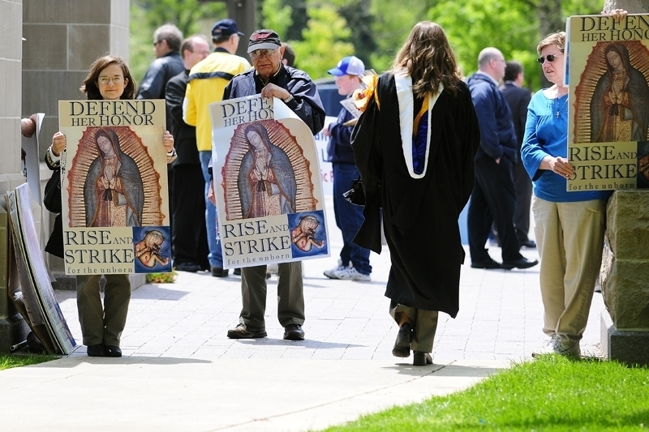A graduate student walks past protesters as she leaves the campus gates Saturday (May 16, 2009)
IAN GAVLICK/The Observer
http://media.collegepublisher.com/media/paper660/stills/e9g9ooc9.jpg
_____________________________________________________________________________
_____________________________________________________________________________

Obama is controlled by the Pope / Jesuits / Jesuit General - the NEW WORLD ORDER
www.shatteringdenial.com/white_papal_masters.html

Obama's Jesuit / Vatican Connection - Catholic Advisors
www.shatteringdenial.com/obama4.html

Democratic presidential nominee U.S. Sen. Barack Obama (D-IL) sitting next to
Archbishop of New York, Cardinal Edward Egan (C) at the 2008 Alfred E. Smith Dinner
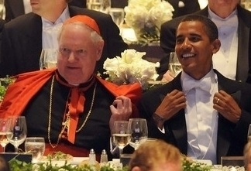
at the Waldorf Astoria Hotel October 16, 2008 in New York City.
Rome and US Presidential Candidates - Vatican's New World Order in the open - "Hidden in Plain View"
Rome's Catholic Archbishop of New York, Cardinal Egan, with CFR's McCain and Marxist Obama
Rome's New World Order in operation - "Hidden in Plain View"
-Vatican's Roman Catholic Archbishop of New York Cardinal Edward Egan
- Pro-Abort, Pro-Sodomite, NWO Globalist, CFR-member, John "McAmnesty" McCain
- Pro-Abort, Pro-Sodomite, NWO Globalist, Marxist, Barack "Citizen of the World" Obama
http://lefemineforlife.blogspot.com/2008/10/rome-and-us-presidential-candidates.html

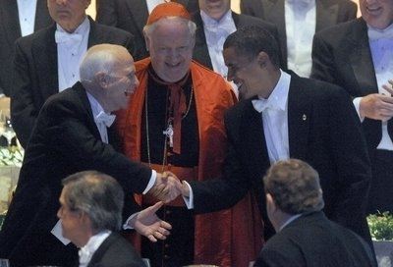
Democratic presidential nominee U.S. Sen. Barack Obama (D-IL) (R) shakes hands
with Republican presidential nominee Sen. John McCain (R-AZ) (L) as the Archbishop of New York,
Cardinal Edward Egan (C) looks on at the 2008 Alfred E. Smith Dinner at the Waldorf Astoria Hotel
October 16, 2008 in New York City. Appearing at the Alfred Smith dinner is a tradition for
presidential candidates, with both major nominees usually attending during the election year.
(Photo by Getty Images North America)
Photo #23
www.zimbio.com/pictures/T6CEASROP9z/Obama+McCain+Attend+Alfred+E+Smith+Memorial/02gJTClfAM9/Barack+Obama
http://pigs-in-the-parlor.blogspot.com/

_____________________________________________________________________________

Pope calls for a new world order [CNN]
www.scribd.com/doc/2905949/cnn

Pope calls for a new world order
www.guardian.co.uk/world/2004/jan/02/catholicism.religion

"Pope John Paul II launched one of the most important diplomatic initiatives of his long papacy ...
when he called for a new international order to replace the one that emerged from the second world war."
"The Pope called ... for the reform of world institutions and deplored any failure to respect international law."
" "More than ever, we need a new international order that draws on the experience and results achieved
in these years by the United Nations," he [ the Pope ] declared..."

The Vatican / Papal / Jesuit New World Order is about:
1) one-world government (UN, G-20, G-8, EU, NATO, NAFTA, WTO, CAFTA, SPP, NAU, ad nauseam)
2) one-world money (Euro, Amero, Federal Reserve, World Bank, IMF, ad nauseam)
3) one-world religion (Ecumenism - all the world's false religions under Rome's Vatican)
4) global population reduction (abortion, birth control, disease, famine, and war are all "instruments"
of this satanic policy objective - by possibly 90% -
www.radioliberty.com/stones.htm / www.radioliberty.com/pca.htm )

ROME is the New World Order.

The New World Order is a plan for global, one-world socialist tyranny, where the God-given,
unalienable rights of Americans that were protected by the United States Constitution and
the Bill of Rights, will no longer be protected, but superseded by an Anti-Christian, Anti-Bible,
Anti-Messiah Global Government. Bible-believing Christians are called to RESIST
Rome's New World Order, in the Name of the Lord !

"They that forsake the law praise the wicked: but such as keep the law contend with them."
Proverb 28:4, KJB

"... where the Spirit of the Lord is, there is liberty." 2 Corinthians 3:17b, KJB

... and where the Spirit of the Lord is absent, there is chaos, and then tyranny.

Steve Lefemine
April 3, 2009 / Revised May 14, 2009

_____________________________________________________________________________
_____________________________________________________________________________

Bible-believing Christian pro-lifers: "BE YE NOT UNEQUALLY YOKED" with ROME at NOTRE DAME

CHRISTIANS: Love God first, then your unborn neighbor !
Matthew 22:37-39

2 Corinthians 6:14-18, King James Bible
www.bartleby.com/108/47/6.html#S10

Ye Are the Temple of the Living God

14 ¶ Be ye not unequally yoked together with unbelievers: for what fellowship hath righteousness with unrighteousness?
and what communion hath light with darkness?

15 And what concord hath Christ with Be'li-al? or what part hath he that believeth with an infidel?

16 And what agreement hath the temple of God with idols? for ye are the temple of the living God; 1 Cor. 3.16 ; 6.19
as God hath said, I will dwell in them, and walk in them; and I will be their God,
and they shall be my people. Lev. 26.12 · Ezek. 37.27

17 Wherefore come out from among them, and be ye separate, saith the Lord,
and touch not the unclean thing; Is. 52.11
and I will receive you,

18 and will be a Father unto you,
and ye shall be my sons and daughters, 2 Sam. 7.14 · 1 Chr. 17.13
saith the Lord Almighty.

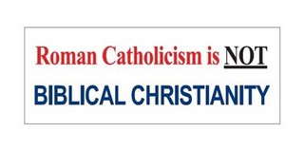
Make no mistake, Barack Obama has no business, Biblically-speaking, even being President,
let alone speaking at any college commencement, and receiving an honorary degree. His election
is a sign of God's Judgement upon America by giving us wicked rulers because we as a country are
wicked (e.g., Isaiah 3:12, Psalm 106:37-44). When America ceases to be a nation of baby-murderers,
fornicators, and sodomites, we'll be on the road to God bringing healing instead of judgement to America. Judgement begins first in the house of God (1 Peter 4:17). Christians must repent (2 Chronicles 7:14).

Biblical Standards for Choosing Civil Magistrates
by William Einwechter, July 7, 2004
www.visionforumministries.org/issues/ballot_box/biblical_standards_for_choosin.aspx

For the University of Notre Dame to honor this wicked man is a disgrace, and something that those
who profess to be pro-life Roman Catholics should rightly oppose. However that does not imply
that Bible-believing, born-again Christians should yoke with Roman Catholics in this fight.

What Does The Bible Say About Separation?
Fundamental Evangelistic Association
www.feasite.org/Tracts/fbcsepr1.htm
"THE BIBLICAL DOCTRINE OF SEPARATION is based on one of God's essential attributes- His holiness."

Notre Dame's famous golden dome with its statue of the Roman goddess Virgin "Mary"

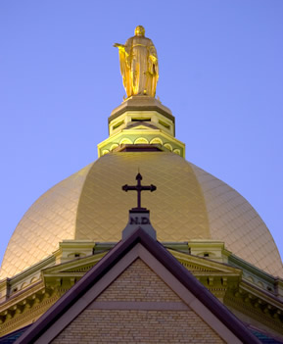
http://nd.edu/campus-and-community/sights-sounds/virtual-tour/main-building-int/#tour-nav

_____________________________________________________________________________

Love God even "More Than These"

The seminal work in presenting, documenting, and denouncing the unfortunate ecumenical nature
of the pro-life movement, including the "rescue" movement, which courageously and in a spirit of repentance, conducted nonviolent sit-ins in front of abortion mill death camps in an effort to save
the lives of pre-birth human beings scheduled for slaughter, is a book which the CCL director (who
was a part of ecumenical pro-life activity until leaving Operation Save America, a successor to
Operation Rescue, at the end of 2005) highly recommends for the reading of Christian pro-lifers.
The book's author (who also participated in the "rescue" movement) is Mr. Ralph Ovadal, pastor of Pilgrims Covenant Church, Monroe, Wisconsin, a veteran of pro-life activism.

Pilgrim Covenant Church Tracts, Books
www.pccmonroe.org/Resources.htm

More Than These: A Call for Reformation
By Pastor Ralph Ovadal, 270 pages
Gift of $8 per copy
Now available online! Click here to read!

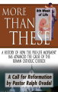

An Urgent Plea to Roman Catholics
Gift of $.07 each (Group 2)

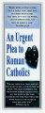
_____________________________________________________________________________ Call for Reformation
Resources from Chick Publications: www.chick.com

Are Roman Catholics Christians?
Catholics trust in their religion and good works for salvation, but neither can save. Only Jesus can!
www.chick.com/reading/tracts/0071/0071_01.asp

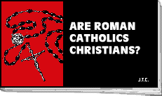
Are Roman Catholics Christians?
©1985 by Jack T. Chick LLC
- E-mail this tract to a friend.

The Death Cookie
Introduces Catholics to the real Bread of Life, Jesus Christ.
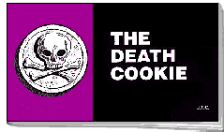
www.chick.com/reading/tracts/0074/0074_01.asp

Death Cookie, The
©1988 by Jack T. Chick LLC
- E-mail this tract to a friend.
Why Is Mary Crying?
Devotion to Mary doesn't please her. It breaks her heart.
www.chick.com/reading/tracts/0040/0040_01.asp

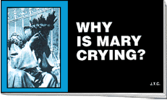
Why Is Mary Crying?
©1987 by Jack T. Chick LLC
- E-mail this tract to a friend.
_____________________________________________________________________________
_____________________________________________________________________________

Roman Catholicism is NOT Biblical Christianity
http://lefemineforlife.blogspot.com/2008/04/roman-catholicism-is-not-biblical.html
Five Reasons Why Roman Catholicism is not Biblical Christianity
www.ianpaisley.org/tiara.asp?printerfriendly=true

Evangelism to Roman Catholics by a former Roman Catholic priest:
The www.bereanbeacon.org/ website is the ministry outreach of former Catholic priest Richard Bennett.

Pope Benedict XVI: True or False Shepherd?
www.sermonaudio.com/sermoninfo.asp?SID=42608108410
4/20/2008 (SUN) | John 10 (57:04)
Sermon by Mr. John Wagner, pastor
Covenant Free Presbyterian Church, Lexington, South Carolina

Romanism and Islam are both rooted in the pagan religion of ancient Babylon.
Roman Catholicism is NOT Biblical Christianity.

The Pope Kissing The Koran
(Karol Wojtyla - "Pope John Paul II")
www.deceptioninthechurch.com/popekiss.html

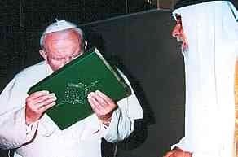
Here (above) is a photo of the Pope at the end of an audience with Patriarch Raphael I of Iraq where "the Pope bowed to the Muslim holy book the Qu'ran presented to him by the delegation and kissed it as a sign of respect".

"The Two Babylons - Romanism and Its Origins," by Alexander Hislop (1916):
www.chick.com/catalog/books/0185.asp

"Where did the practices and beliefs of Roman Catholicism come from? In this scholarly classic, first published over eighty years ago, Alexander Hislop reveals that many Roman Catholic teachings did not originate with Christ or the Bible, but were adopted from ancient pagan Babylonian religion, and given Christian names."

Roman Catholic Inquisition and The Torture Tools (Video)
"The Inquisition ..."
"... the 605 Years of Torture and Murder that was Inflicted on Bible-believing Christians [ by Rome ]
because they refused to compromise their faith."
Posted to YouTube March 07, 2007
Video (58:27) Views: 229,273 (5/16/2009)
(Report prepared February 25, 2009)
www.christianlifeandliberty.net/2009-02-25-Roman-Catholic-Inquisition-Torture-Tools-Video.doc

_____________________________________________________________________________
_____________________________________________________________________________

"... I will build My church; and the gates of hell shall not prevail against it." Matthew 16:18
Yeshua Messiah

Hallelu-Yah !

Steve Lefemine, pro-life missionary
dir., Columbia Christians for Life
PO Box 50358
Columbia, SC
(803) 794-6273
www.ChristianLifeandLiberty.net
www.RighttoLifeActofSC.net
www.LefemineForLife.net
May 16, 2009

